
Sri Venkateswara University,
Tirupati
Convocation Admit Card Letter – Help Manual

June 4, 2026

Self Service

- Login to the Self Service by clicking the URL Link below.
https://www.tcsion.com/SelfServices/
- Input the Login ID and Password.

Login ID: RegistrationNumber@svu.in (Eg: 123456@svu.in)
Password: Svu@2026

- Click on “Login”.

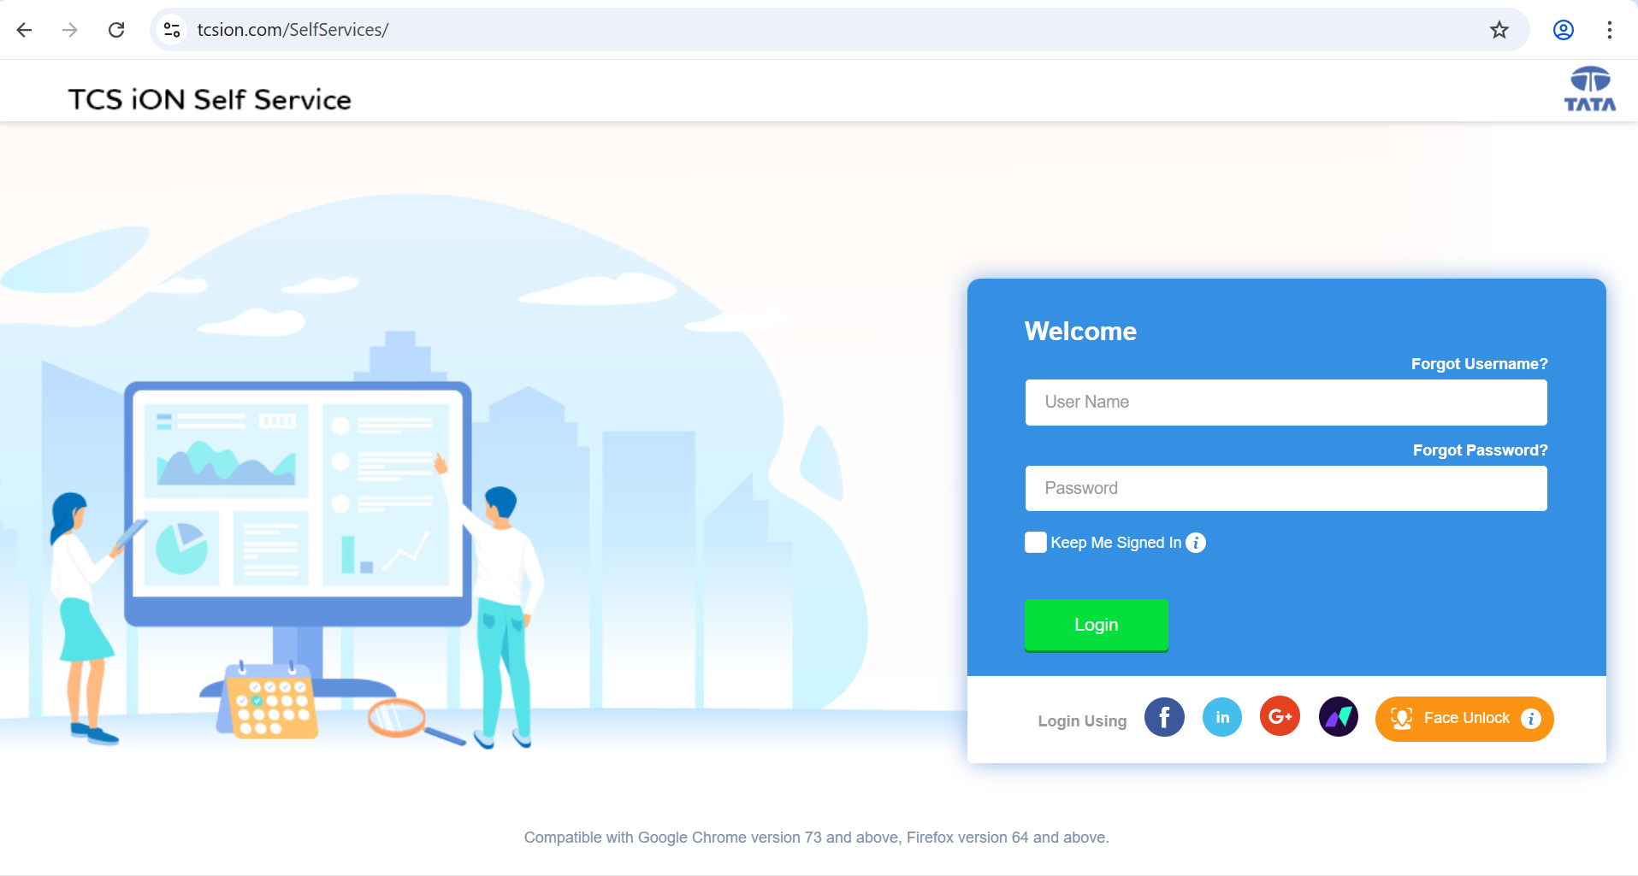
- After logging in successfully, it will be redirected to the Homepage of Student Dashboard. Now click Convocation Admit Card Aero icon located in Left side, it will be redirected to Letter printing screen.
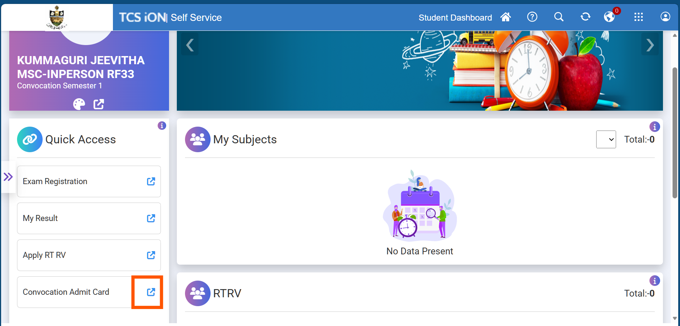
- In the Letter Printing screen, just click on Search button, without giving any input in any fields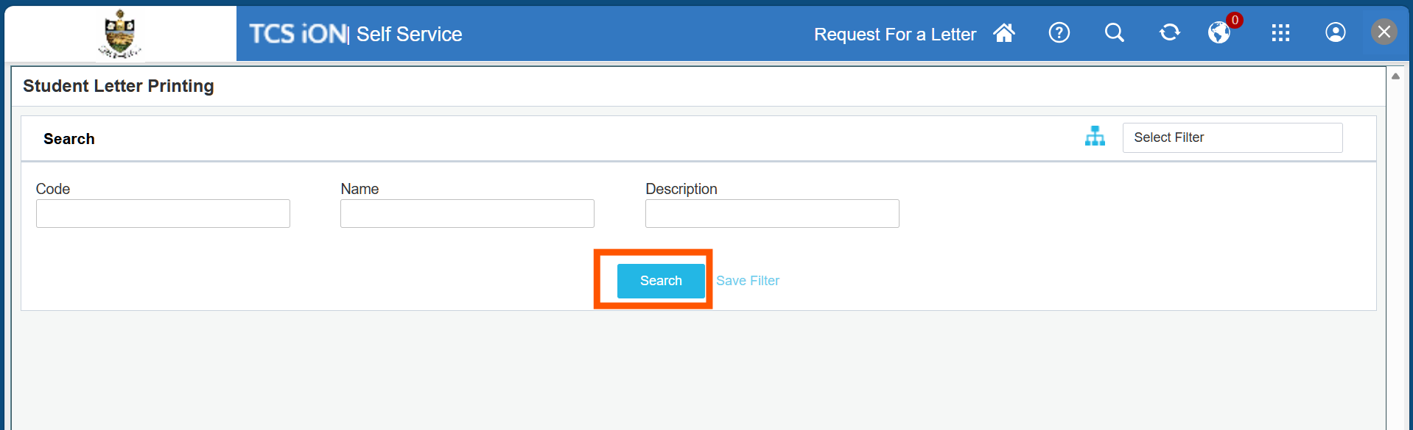

- Here you will get Convocation Admit Card Letter row and Click Letter Button.
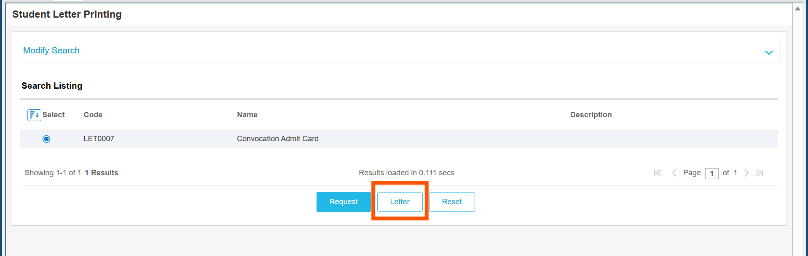
- Now Convocation Admit Card will open in new screen, here you can take Print as PDF.

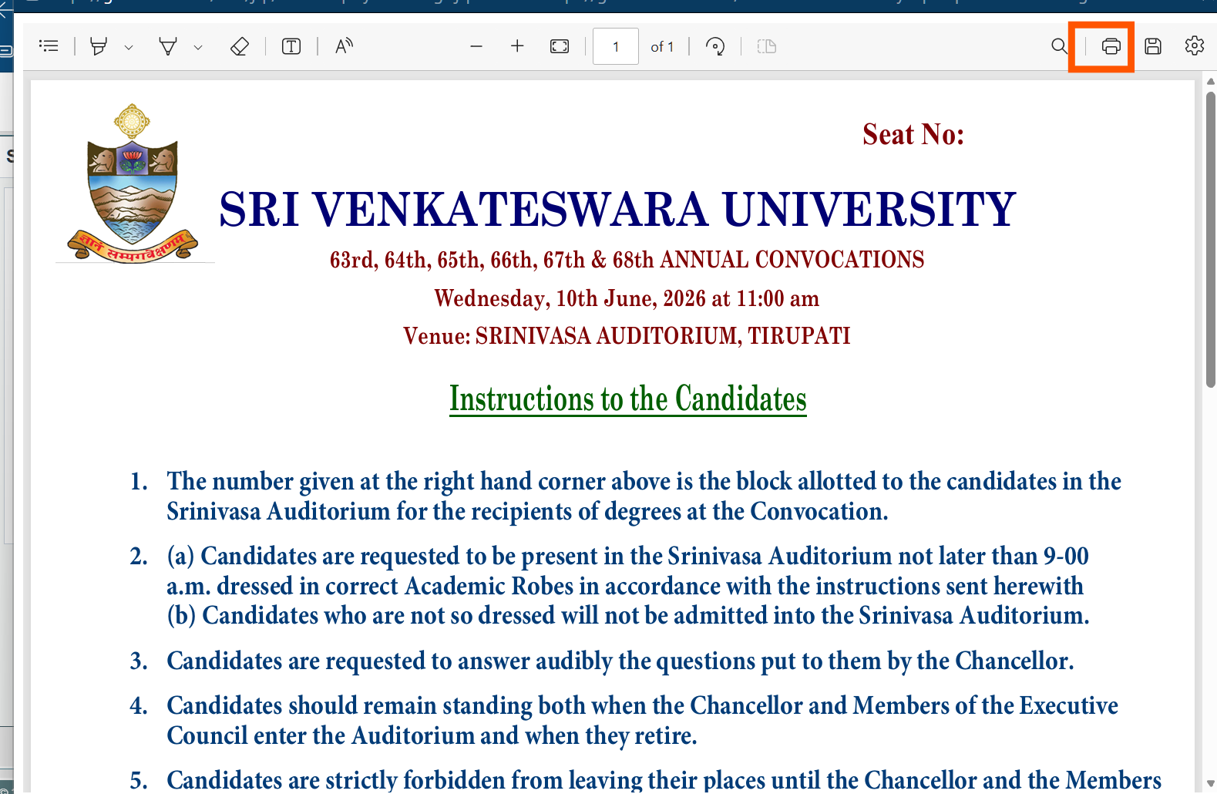

End of the Document

